#Load needed libraries
library(ggplot2)
library(tidyverse)
# Problem 1: Generate a list of datasets within R itself
> ls("package:datasets")
[1] "ability.cov" "airmiles" "AirPassengers" "airquality" "anscombe"
[6] "attenu" "attitude" "austres" "beaver1" "beaver2"
[11] "BJsales" "BJsales.lead" "BOD" "cars" "ChickWeight"
[16] "chickwts" "co2" "CO2" "crimtab" "discoveries"
[21] "DNase" "esoph" "euro" "euro.cross" "eurodist"
[26] "EuStockMarkets" "faithful" "fdeaths" "Formaldehyde" "freeny"
[31] "freeny.x" "freeny.y" "gait" "HairEyeColor" "Harman23.cor"
[36] "Harman74.cor" "Indometh" "infert" "InsectSprays" "iris"
[41] "iris3" "islands" "JohnsonJohnson" "LakeHuron" "ldeaths"
[46] "lh" "LifeCycleSavings" "Loblolly" "longley" "lynx"
[51] "mdeaths" "morley" "mtcars" "nhtemp" "Nile"
[56] "nottem" "npk" "occupationalStatus" "Orange" "OrchardSprays"
[61] "penguins" "penguins_raw" "PlantGrowth" "precip" "presidents"
[66] "pressure" "Puromycin" "quakes" "randu" "rivers"
[71] "rock" "Seatbelts" "sleep" "stack.loss" "stack.x"
[76] "stackloss" "state.abb" "state.area" "state.center" "state.division"
[81] "state.name" "state.region" "state.x77" "sunspot.m2014" "sunspot.month"
[86] "sunspot.year" "sunspots" "swiss" "Theoph" "Titanic"
[91] "ToothGrowth" "treering" "trees" "UCBAdmissions" "UKDriverDeaths"
[96] "UKgas" "USAccDeaths" "USArrests" "UScitiesD" "USJudgeRatings"
[101] "USPersonalExpenditure" "uspop" "VADeaths" "volcano" "warpbreaks"
[106] "women" "WorldPhones" "WWWusage"

#Problem 2: Generate a list of datasets within the package ggplot2
data(package = "ggplot2")
Data sets in package ‘ggplot2’:

diamonds Prices of over 50,000 round cut diamonds
economics US economic time series
economics_long US economic time series
faithfuld 2d density estimate of Old Faithful data
luv_colours 'colors()' in Luv space
midwest Midwest demographics
mpg Fuel economy data from 1999 to 2008 for 38 popular models of cars
msleep An updated and expanded version of the mammals sleep dataset
presidential Terms of 12 presidents from Eisenhower to Trump
seals Vector field of seal movements
txhousing Housing sales in TX

#Problem 3 Use head, tail, str, name, glimpse, class on a dataset of Midwest
> head(midwest)
# A tibble: 6 × 28
PID county state area poptotal popdensity popwhite popblack popamerindian popasian popother percwhite percblack percamerindan
<int> <chr> <fct> <dbl> <int> <dbl> <int> <int> <int> <int> <int> <dbl> <dbl> <dbl>
1 561 ADAMS IL 0.052 66090 1271. 63917 1702 98 249 124 96.7 2.58 0.148
2 562 ALEXANDER IL 0.014 10626 759 7054 3496 19 48 9 66.4 32.9 0.179
3 563 BOND IL 0.022 14991 681. 14477 429 35 16 34 96.6 2.86 0.233
4 564 BOONE IL 0.017 30806 1812. 29344 127 46 150 1139 95.3 0.412 0.149
5 565 BROWN IL 0.018 5836 324. 5264 547 14 5 6 90.2 9.37 0.240
6 566 BUREAU IL 0.05 35688 714. 35157 50 65 195 221 98.5 0.140 0.182
# ℹ 14 more variables: percasian <dbl>, percother <dbl>, popadults <int>, perchsd <dbl>, percollege <dbl>, percprof <dbl>,
# poppovertyknown <int>, percpovertyknown <dbl>, percbelowpoverty <dbl>, percchildbelowpovert <dbl>, percadultpoverty <dbl>,
# percelderlypoverty <dbl>, inmetro <int>, category <fct>

> tail(midwest)
# A tibble: 6 × 28
PID county state area poptotal popdensity popwhite popblack popamerindian popasian popother percwhite percblack percamerindan
<int> <chr> <fct> <dbl> <int> <dbl> <int> <int> <int> <int> <int> <dbl> <dbl> <dbl>
1 3047 WASHINGTON WI 0.025 95328 3813. 94465 125 208 337 193 99.1 0.131 0.218
2 3048 WAUKESHA WI 0.034 304715 8962. 298313 1096 672 2699 1935 97.9 0.360 0.221
3 3049 WAUPACA WI 0.045 46104 1025. 45695 22 125 92 170 99.1 0.0477 0.271
4 3050 WAUSHARA WI 0.037 19385 524. 19094 29 70 43 149 98.5 0.150 0.361
5 3051 WINNEBAGO WI 0.035 140320 4009. 136822 697 685 1728 388 97.5 0.497 0.488
6 3052 WOOD WI 0.048 73605 1533. 72157 90 481 722 155 98.0 0.122 0.653
# ℹ 14 more variables: percasian <dbl>, percother <dbl>, popadults <int>, perchsd <dbl>, percollege <dbl>, percprof <dbl>,
# poppovertyknown <int>, percpovertyknown <dbl>, percbelowpoverty <dbl>, percchildbelowpovert <dbl>, percadultpoverty <dbl>,
# percelderlypoverty <dbl>, inmetro <int>, category <fct>

> str(midwest)
tibble [437 × 28] (S3: tbl_df/tbl/data.frame)
$ PID : int [1:437] 561 562 563 564 565 566 567 568 569 570 ...
$ county : chr [1:437] "ADAMS" "ALEXANDER" "BOND" "BOONE" ...
$ state : Factor w/ 5 levels "IL","IN","MI",..: 1 1 1 1 1 1 1 1 1 1 ...
$ area : num [1:437] 0.052 0.014 0.022 0.017 0.018 0.05 0.017 0.027 0.024 0.058 ...
$ poptotal : int [1:437] 66090 10626 14991 30806 5836 35688 5322 16805 13437 173025 ...
$ popdensity : num [1:437] 1271 759 681 1812 324 ...
$ popwhite : int [1:437] 63917 7054 14477 29344 5264 35157 5298 16519 13384 146506 ...
$ popblack : int [1:437] 1702 3496 429 127 547 50 1 111 16 16559 ...
$ popamerindian : int [1:437] 98 19 35 46 14 65 8 30 8 331 ...
$ popasian : int [1:437] 249 48 16 150 5 195 15 61 23 8033 ...
$ popother : int [1:437] 124 9 34 1139 6 221 0 84 6 1596 ...
$ percwhite : num [1:437] 96.7 66.4 96.6 95.3 90.2 ...
$ percblack : num [1:437] 2.575 32.9 2.862 0.412 9.373 ...
$ percamerindan : num [1:437] 0.148 0.179 0.233 0.149 0.24 ...
$ percasian : num [1:437] 0.3768 0.4517 0.1067 0.4869 0.0857 ...
$ percother : num [1:437] 0.1876 0.0847 0.2268 3.6973 0.1028 ...
$ popadults : int [1:437] 43298 6724 9669 19272 3979 23444 3583 11323 8825 95971 ...
$ perchsd : num [1:437] 75.1 59.7 69.3 75.5 68.9 ...
$ percollege : num [1:437] 19.6 11.2 17 17.3 14.5 ...
$ percprof : num [1:437] 4.36 2.87 4.49 4.2 3.37 ...
$ poppovertyknown : int [1:437] 63628 10529 14235 30337 4815 35107 5241 16455 13081 154934 ...
$ percpovertyknown : num [1:437] 96.3 99.1 95 98.5 82.5 ...
$ percbelowpoverty : num [1:437] 13.15 32.24 12.07 7.21 13.52 ...
$ percchildbelowpovert: num [1:437] 18 45.8 14 11.2 13 ...
$ percadultpoverty : num [1:437] 11.01 27.39 10.85 5.54 11.14 ...
$ percelderlypoverty : num [1:437] 12.44 25.23 12.7 6.22 19.2 ...
$ inmetro : int [1:437] 0 0 0 1 0 0 0 0 0 1 ...
$ category : Factor w/ 16 levels "AAR","AAU","AHR",..: 1 15 1 6 1 1 13 1 1 8 ...

> names(midwest)
[1] "PID" "county" "state" "area" "poptotal"
[6] "popdensity" "popwhite" "popblack" "popamerindian" "popasian"
[11] "popother" "percwhite" "percblack" "percamerindan" "percasian"
[16] "percother" "popadults" "perchsd" "percollege" "percprof"
[21] "poppovertyknown" "percpovertyknown" "percbelowpoverty" "percchildbelowpovert" "percadultpoverty"
[26] "percelderlypoverty" "inmetro" "category"

> glimpse(midwest)
Rows: 437
Columns: 28
$ PID <int> 561, 562, 563, 564, 565, 566, 567, 568, 569, 570, 571, 572, 573, 574, 575, 576, 577, 578, 579, 580, 581, 582…
$ county <chr> "ADAMS", "ALEXANDER", "BOND", "BOONE", "BROWN", "BUREAU", "CALHOUN", "CARROLL", "CASS", "CHAMPAIGN", "CHRIST…
$ state <fct> IL, IL, IL, IL, IL, IL, IL, IL, IL, IL, IL, IL, IL, IL, IL, IL, IL, IL, IL, IL, IL, IL, IL, IL, IL, IL, IL, …
$ area <dbl> 0.052, 0.014, 0.022, 0.017, 0.018, 0.050, 0.017, 0.027, 0.024, 0.058, 0.042, 0.030, 0.028, 0.029, 0.030, 0.0…
$ poptotal <int> 66090, 10626, 14991, 30806, 5836, 35688, 5322, 16805, 13437, 173025, 34418, 15921, 14460, 33944, 51644, 5105…
$ popdensity <dbl> 1270.9615, 759.0000, 681.4091, 1812.1176, 324.2222, 713.7600, 313.0588, 622.4074, 559.8750, 2983.1897, 819.4…
$ popwhite <int> 63917, 7054, 14477, 29344, 5264, 35157, 5298, 16519, 13384, 146506, 34176, 15842, 14403, 32688, 50177, 32049…
$ popblack <int> 1702, 3496, 429, 127, 547, 50, 1, 111, 16, 16559, 82, 10, 4, 1021, 925, 1317147, 63, 5, 2069, 25, 16, 15462,…
$ popamerindian <int> 98, 19, 35, 46, 14, 65, 8, 30, 8, 331, 51, 26, 17, 48, 92, 10289, 34, 6, 123, 37, 19, 962, 24, 8, 45, 40, 14…
$ popasian <int> 249, 48, 16, 150, 5, 195, 15, 61, 23, 8033, 89, 36, 29, 104, 341, 188565, 48, 26, 1751, 43, 41, 39634, 24, 1…
$ popother <int> 124, 9, 34, 1139, 6, 221, 0, 84, 6, 1596, 20, 7, 7, 83, 109, 384119, 19, 6, 1021, 24, 108, 10703, 10, 6, 29,…
$ percwhite <dbl> 96.71206, 66.38434, 96.57128, 95.25417, 90.19877, 98.51210, 99.54904, 98.29813, 99.60557, 84.67331, 99.29688…
$ percblack <dbl> 2.57527614, 32.90043290, 2.86171703, 0.41225735, 9.37285812, 0.14010312, 0.01878993, 0.66051770, 0.11907420,…
$ percamerindan <dbl> 0.14828264, 0.17880670, 0.23347342, 0.14932156, 0.23989034, 0.18213405, 0.15031943, 0.17851830, 0.05953710, …
$ percasian <dbl> 0.37675897, 0.45172219, 0.10673071, 0.48691813, 0.08567512, 0.54640215, 0.28184893, 0.36298721, 0.17116916, …
$ percother <dbl> 0.18762294, 0.08469791, 0.22680275, 3.69733169, 0.10281014, 0.61925577, 0.00000000, 0.49985123, 0.04465282, …
$ popadults <int> 43298, 6724, 9669, 19272, 3979, 23444, 3583, 11323, 8825, 95971, 22945, 10734, 9647, 21563, 29136, 3291995, …
$ perchsd <dbl> 75.10740, 59.72635, 69.33499, 75.47219, 68.86152, 76.62941, 62.82445, 75.95160, 72.27195, 87.49935, 73.07474…
$ percollege <dbl> 19.63139, 11.24331, 17.03382, 17.27895, 14.47600, 18.90462, 11.91739, 16.19712, 14.10765, 41.29581, 13.56723…
$ percprof <dbl> 4.355859, 2.870315, 4.488572, 4.197800, 3.367680, 3.275891, 3.209601, 3.055727, 3.206799, 17.757448, 3.08999…
$ poppovertyknown <int> 63628, 10529, 14235, 30337, 4815, 35107, 5241, 16455, 13081, 154934, 33788, 15615, 14248, 32190, 45693, 5023…
$ percpovertyknown <dbl> 96.27478, 99.08714, 94.95697, 98.47757, 82.50514, 98.37200, 98.47802, 97.91729, 97.35060, 89.54429, 98.16956…
$ percbelowpoverty <dbl> 13.151443, 32.244278, 12.068844, 7.209019, 13.520249, 10.399635, 15.149781, 11.710726, 13.875086, 15.572437,…
$ percchildbelowpovert <dbl> 18.011717, 45.826514, 14.036061, 11.179536, 13.022889, 14.158819, 13.787761, 17.225462, 17.994784, 14.132234…
$ percadultpoverty <dbl> 11.009776, 27.385647, 10.852090, 5.536013, 11.143211, 8.179287, 12.932331, 10.027037, 11.914343, 17.562728, …
$ percelderlypoverty <dbl> 12.443812, 25.228976, 12.697410, 6.217047, 19.200000, 11.008586, 21.085271, 9.525052, 13.660180, 8.105017, 1…
$ inmetro <int> 0, 0, 0, 1, 0, 0, 0, 0, 0, 1, 0, 0, 0, 1, 0, 1, 0, 0, 1, 0, 0, 1, 0, 0, 0, 0, 0, 0, 0, 0, 0, 1, 0, 0, 0, 0, …
$ category <fct> AAR, LHR, AAR, ALU, AAR, AAR, LAR, AAR, AAR, HAU, AAR, AAR, LAR, LAU, AAR, AAU, AAR, AAR, HAU, AAR, AAR, HLU…

> class(midwest)
[1] "tbl_df" "tbl" "data.frame"

#Problem 4 Create a horizontal bar chart on data in midwest
> ggplot(midwest)+geom_bar(aes(y=state))
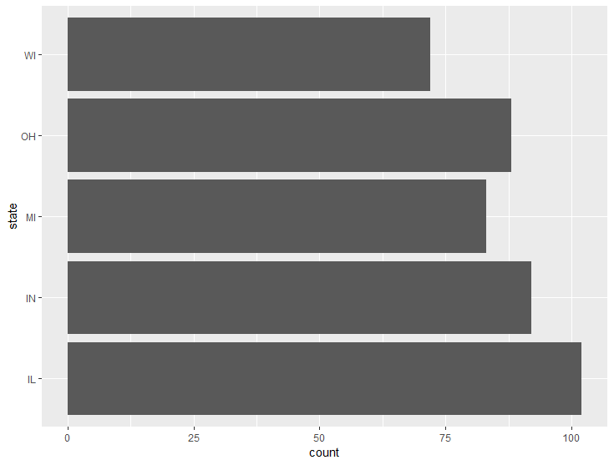
#Problem 5 Create a vertical bar chart on data in midwest
> ggplot(midwest)+geom_bar(aes(y=state))+
labs()+
coord_flip()

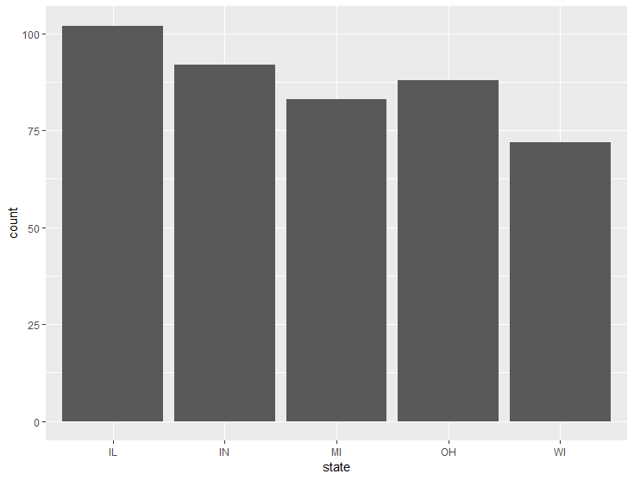

#Problem 6 Create a horizontal stacked bar chart on data in midwest
ggplot(midwest, aes(y=state, fill=category))+
geom_bar(position=position_stack(reverse=TRUE))+
theme(legend.position="top")

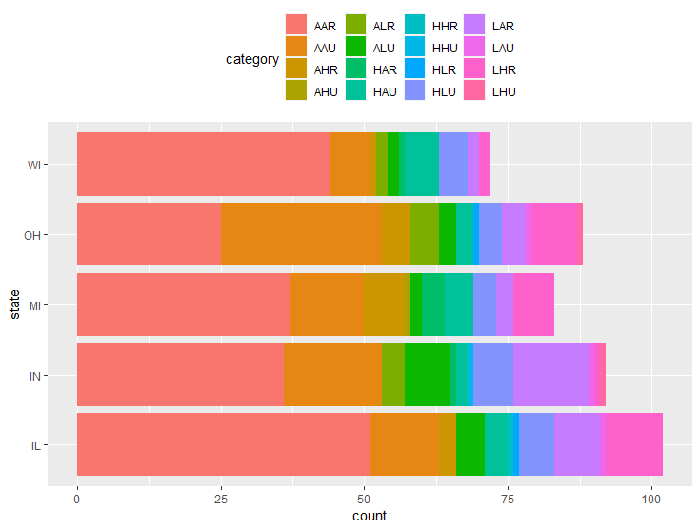

#Problem 7 Create a vertical stacked bar chart on data in midwest
midwest$state<-factor(midwest$state)
midwest$category<-factor(midwest$category)
ggplot(data=midwest, aes(x=state, fill=category))+
geom_bar()+
xlab("State")+
ggtitle("Category")

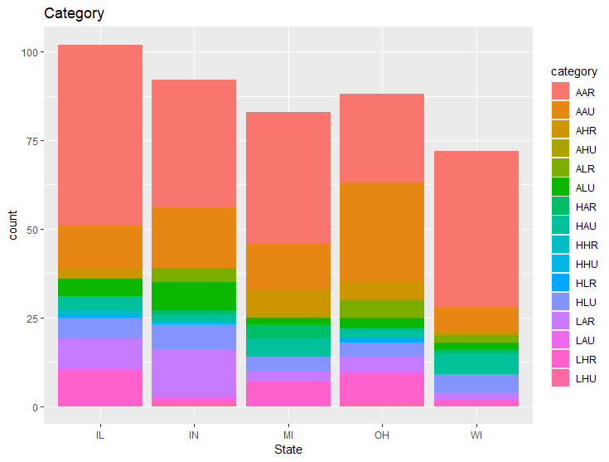

#Problem 8 Create a scatterplot on data in midwest
ggplot(midwest, aes(x=area, y=popdensity))+
geom_point()+
xlab("Area")+
ylab("Population Density")

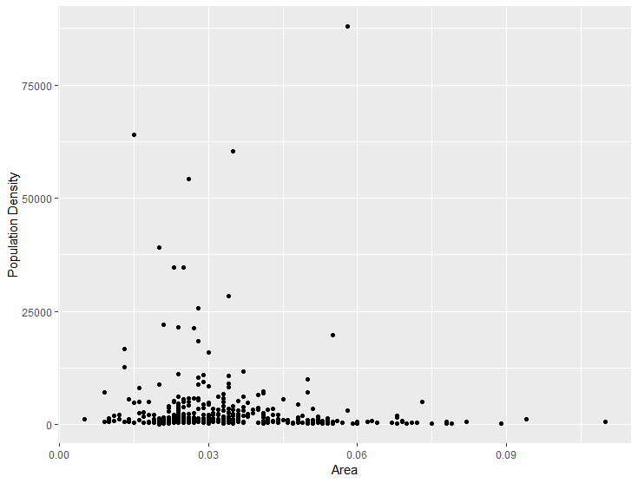

#Problem 9 Create a line chart on data in midwest
ggplot(midwest, aes(x=area, y=popdensity))+
geom_line()

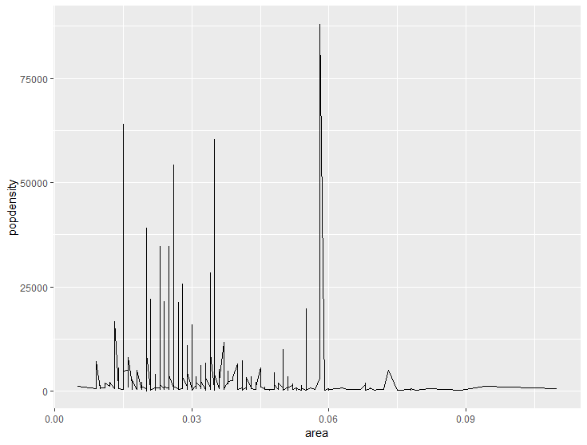

#Problem 10 Create a histogram on data in midwest
ggplot(midwest, aes(x=popdensity))+
geom_histogram(fill="purple",alpha=0.7, binwidth=10000)+
xlab("pop density")+
ylab("Frequency")+
theme_bw()
geom_histogram(fill="purple", alpha=0.7, binwidth=10000) +
xlab("pop density") +
ylab("Frequency") +
theme_bw()

